Java is one of the most widely used programming languages in top tech companies due to its reliability, scalability, and performance. It is a popular choice for building enterprise-level applications and backend systems. This article provides a comprehensive list of 200+ Core Java interview questions for both freshers and experienced developers.
- Covers frequently asked Core Java interview questions
- Suitable for both beginners and experienced professionals
- Helps in quick revision and interview preparation

Java Interview questions for Freshers

1. Is Java Platform Independent?
Java is a platform-independent programming language because its source code is compiled into bytecode rather than machine-specific code. This bytecode can run on any operating system that has a compatible Java Virtual Machine (JVM) installed.
- The javac compiler converts Java source code into platform-independent bytecode (.class file).
- A JVM is available for different operating systems, allowing the same bytecode to run everywhere.
- This enables Java to follow the principle "Write Once, Run Anywhere (WORA)."

2. What are the top Java Features?
Java is one the most famous and most used language in the real world, there are many features in Java that makes it better than any other language some of them are mentioned below:
Features of Java
- Simple: Java is quite simple to understand and the syntax
- Platform Independent: Java is platform independent means we can run the same program in any software and hardware and will get the same result.
- Interpreted: Java is interpreted as well as a compiler-based language.
- Robust: features like Garbage collection, exception handling, etc that make the language robust.
- Object-Oriented: Java is an object-oriented language that supports the concepts of class, objects, four pillars of OOPS, etc.
- Secured: As we can directly share an application with the user without sharing the actual program makes Java a secure language.
- High Performance: faster than other traditional interpreted programming languages.
- Dynamic: supports dynamic loading of classes and interfaces.
- Distributed: feature of Java makes us able to access files by calling the methods from any machine connected.
- Multithreaded: deal with multiple tasks at once by defining multiple threads
- Architecture Neutral: it is not dependent on the architecture.

3. What is JVM?
The Java Virtual Machine (JVM) is a virtual machine that executes Java bytecode and provides a runtime environment for Java applications. It acts as a bridge between the Java program and the underlying operating system.
- JVM loads, verifies, and executes Java bytecode (.class files).
- It provides platform independence by allowing the same bytecode to run on different operating systems.
- JVM also manages memory, garbage collection, and runtime execution.
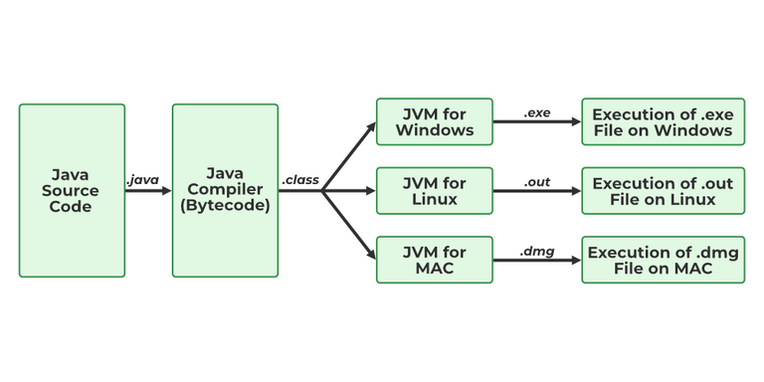JVM

4. What is JIT?
JIT stands for (Just-in-Time) compiler is a part of JRE(Java Runtime Environment), it is used for better performance of the Java applications during run-time. The use of JIT is mentioned in step by step process mentioned below:
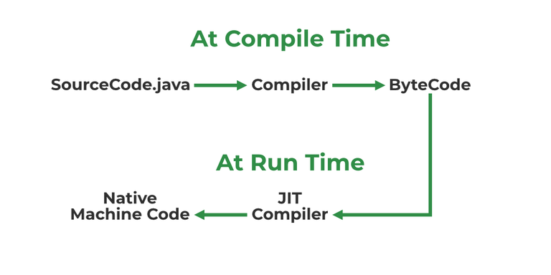JIT
- Source code is compiled with javac to form bytecode
- Bytecode is further passed on to JVM
- JIT is a part of JVM, JIT is responsible for compiling bytecode into native machine code at run time.
- The JIT compiler is enabled throughout, while it gets activated when a method is invoked. For a compiled method, the JVM directly calls the compiled code, instead of interpreting it.
- As JVM calls the compiled code that increases the performance and speed of the execution.

5. What are Memory storages available with JVM?
JVM consists of a few memory storages as mentioned below:
Memory storages
- Class(Method) Area: stores class-level data of every class such as the runtime constant pool, field, and method data, and the code for methods.
- Heap: Objects are created or objects are stored. It is used to allocate memory to objects during run time.
- Stack: stores data and partial results which will be needed while returning value for method and performing dynamic linking
- Program Counter Register: stores the address of the Java virtual machine instruction currently being executed.
- Native Method Stack: stores all the native methods used in the application.

6. What is a classloader?
Classloader is a JVM component responsible for loading Java classes into memory at runtime. It loads classes only when they are needed, improving memory efficiency and application performance.
- Loads .class files into JVM memory dynamically.
- Supports dynamic class loading during program execution.
classloader

7. Difference between JVM, JRE, and JDK.
JVM, JRE, and JDK are the three main components of the Java platform. Together, they provide the environment required to develop, compile, and run Java applications.
- JVM (Java Virtual Machine): Executes Java bytecode and provides platform independence.
- JRE (Java Runtime Environment): Contains JVM and libraries required to run Java applications.
- JDK (Java Development Kit): Contains JRE along with development tools such as the compiler (javac) and debugger.

8. What are the differences between Java and C++?
Java and C++ are both object-oriented programming languages, but they differ in design, memory management, and platform dependency.
Feature | Java | C++
Platform Dependency | Platform-independent (Write Once, Run Anywhere) | Platform-dependent
Memory Management | Automatic through Garbage Collection | Manual using new and delete
Multiple Inheritance | Not supported through classes (uses interfaces) | Supported directly
Pointers | Does not support explicit pointers | Supports pointers
Compilation | Compiles to bytecode and runs on JVM | Compiles directly to machine code
Operator Overloading | Not supported (except + for strings) | Supported

9. Explain public static void main(String args[]) in Java.
The public static void main(String args[]) method is the entry point of a Java application. The JVM looks for this method and starts program execution from here.
- public: Makes the method accessible from anywhere so that the JVM can invoke it.
- static: Allows the method to be called without creating an object of the class.
- void: Specifies that the method does not return any value.
- main: The predefined method name that acts as the starting point of program execution.
- String args[]: Stores command-line arguments passed to the Java program as an array of strings.

10. What is Java String Pool?
The Java String Pool (JSP) is a special memory area inside the heap where Java stores string literals. It helps save memory by reusing existing string objects instead of creating duplicate ones.
- String literals are stored in the String Pool to optimize memory usage.
- If a string already exists in the pool, Java returns the existing reference instead of creating a new object.
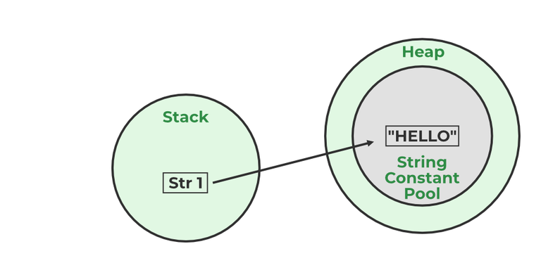Java String Pool
Example:
String str1="Hello";
// "Hello" will be stored in String Pool
// str1 will be stored in stack memory

11. What will happen if we don't declare the main as static?
We can declare the main method without using static and without getting any errors. But, the main method will not be treated as the entry point to the application or the program.

12. What are Packages in Java?
Packages in Java can be defined as the grouping of related types of classes, interfaces, etc providing access to protection and namespace management.

13. Why Packages are used?
Packages are used in Java in order to prevent naming conflicts, control access, and make searching/locating and usage of classes, interfaces, etc easier.

14. What are the advantages of Packages in Java?
There are various advantages of defining packages in Java.
- Packages avoid name clashes.
- The Package provides easier access control.
- We can also have the hidden classes that are not visible outside and are used by the package.
- It is easier to locate the related classes.

15. How many types of packages are there in Java?
There are two types of packages in Java
- User-defined packages
- Build In packages

16. Explain different data types in Java.
There are 2 types of data types in Java as mentioned below:

Primitive Data Type: Primitive data are single values with no special capabilities. There are 8 primitive data types:
- boolean: stores value true or false
- byte: stores an 8-bit signed two's complement integer
- char: stores a single 16-bit Unicode character
- short: stores a 16-bit signed two’s complement integer
- int: stores a 32-bit signed two’s complement integer
- long: stores a 64-bit two’s complement integer
- float: stores a single-precision 32-bit IEEE 754 floating-point
- double: stores a double-precision 64-bit IEEE 754 floating-point
Non-Primitive Data Type: Reference Data types will contain a memory address of the variable's values because it is not able to directly store the values in the memory. Types of Non-Primitive are mentioned below:
- String: Stores a sequence of characters.
- Array: Stores multiple values of the same type.
- Class: Blueprint for creating objects.
- Object: Instance of a class.
- Interface: Defines a contract that classes can implement.

17. When a byte datatype is used?
A byte is an 8-bit signed two-complement integer. The minimum value supported by bytes is -128 and 127 is the maximum value. It is used in conditions where we need to save memory and the limit of numbers needed is between -128 to 127.

18. Can we declare Pointer in Java?
No, Java doesn't provide the support of Pointer. As Java needed to be more secure because which feature of the pointer is not provided in Java.

19. What is the default value of byte datatype in Java?
The default value of the byte datatype in Java is 0.

20. What is the default value of float and double datatype in Java?
The default value of the float is 0.0f and of double is 0.0d in Java.

21. What is the Wrapper class in Java?
A Wrapper Class is a class that converts a primitive data type into an object and vice versa. It allows primitive values to be used where objects are required, such as in collections and generic classes.
- Each primitive data type has a corresponding wrapper class (e.g., int -> Integer, char -> Character, double → Double).
- Wrapper classes support features such as autoboxing (primitive to object) and unboxing (object to primitive).

22. Why do we need wrapper classes?
The wrapper class is an object class that encapsulates the primitive data types, and we need them for the following reasons:
- Wrapper classes are final and immutable
- Provides methods like valueOf(), parseInt(), etc.
- It provides the feature of autoboxing and unboxing.

23. Differentiate between instance and local variables.
Instance Variable | Local Variable
Declared outside the method, directly invoked by the method. | Declared within the method.
Has a default value. | No default value
It can be used throughout the class. | The scope is limited to the method.

24. What are the default values assigned to variables and instances in Java?
In Java When we haven’t initialized the instance variables then the compiler initializes them with default values. The default values for instances and variables depend on their data types. Some common types of default data types are:
- The default value for numeric types (byte, short, int, long, float, and double) is 0.
- The default value for the boolean type is false.
- The default value for object types (classes, interfaces, and arrays) is null.
- The null character, "u0000, " is the default value for the char type.
Example:
// Java Program to demonstrate use of default values
import java.io.*;
class GFG {
// static values
static byte b;
static int i;
static long l;
static short s;
static boolean bool;
static char c;
static String str;
static Object object;
static float f;
static double d;
static int[] Arr;
public static void main(String[] args)
{
// byte value
System.out.println("byte value" + b);
// short value
System.out.println("short value" + s);
// int value
System.out.println("int value" + i);
// long value
System.out.println("long value" + l);
System.out.println("boolean value" + bool);
System.out.println("char value" + c);
System.out.println("float value" + f);
System.out.println("double value" + d);
System.out.println("string value" + str);
System.out.println("object value" + object);
System.out.println("Array value" + Arr);
}
}
Output:
byte value0
short value0
int value0
long value0
boolean valuefalse
char value
float value0.0
double value0.0
string valuenull
object valuenull
Array valuenull

25. What is a Class Variable?
A class variable (also known as a static variable) is a variable that is declared inside a class using the static keyword. It belongs to the class itself rather than to individual objects and is shared among all instances of the class.
- Declared using the static keyword inside a class but outside methods, constructors, and blocks.
- Only one copy of the variable exists, regardless of how many objects are created.
- Can be accessed using the class name without creating an object.
class GFG {
public static int ctr = 0;
public GFG() { ctr++; }
public static void main(String[] args)
{
GFG obj1 = new GFG();
GFG obj2 = new GFG();
GFG obj3 = new GFG();
System.out.println("Number of objects created are "
+ GFG.ctr);
}
}
Output
Number of objects created are 3

26. What is the default value stored in Local Variables?
There is no default value stored with local variables. Also, primitive variables and objects don't have any default values.

27. Explain the difference between instance variable and a class variable.
Both instance variables and class variables are declared inside a class, but they differ in ownership and memory allocation. An instance variable belongs to an object, whereas a class variable belongs to the class itself.
Instance Variable | Class Variable
Declared without the static keyword. | Declared using the static keyword.
Each object gets its own separate copy. | A single copy is shared by all objects.
Memory is allocated when an object is created. | Memory is allocated once when the class is loaded.
Accessed using an object reference. | Can be accessed using the class name.
Changes affect only that particular object. | Changes are reflected across all objects.

28. What is a static variable?
The static keyword is used to share the same variable or method of a given class. Static variables are the variables that once declared then a single copy of the variable is created and shared among all objects at the class level.

29. What is the difference between System.out, System.err, and System.in?
System.out - It is a PrintStream that is used for writing characters or can be said it can output the data we want to write on the Command Line Interface console/terminal.
import java.io.*;
// Driver Class
class GFG {
// Main Function
public static void main(String[] args)
{
// Use of System.out
System.out.println("");
}
}
System.err - It is used to display error messages.
import java.io.*;
// Driver Class
class GFG {
// Main function
public static void main(String[] args)
{
// Printing error
System.err.println(
"This is how we throw error with System.err");
}
}
Output:
This is how we throw error with System.err
Although, System.err have many similarities both of them have quite a lot of difference also, let us check them.
System.out | System.err
It will print to the standard out of the system. | It will print to the standard error.
It is mostly used to display results on the console. | It is mostly used to output error texts.
It gives output on the console with the default(black) color. | It also gives output on the console but most of the IDEs give it a red color to differentiate.
System.in - It is an InputStream used to read input from the terminal Window. We can't use the System.in directly so we use Scanner class for taking input with the system.in.
import java.util.*;
// Driver Class
class Main {
// Main Function
public static void main(String[] args)
{
// Scanner class with System.in
Scanner sc = new Scanner(System.in);
// Taking input from the user
int x = sc.nextInt();
int y = sc.nextInt();
// Printing the output
System.out.printf("Addition: %d", x + y);
}
}
Output:
3
4
Addition: 7

30. What do you understand by an IO stream?
An I/O (Input/Output) Stream in Java is a flow of data between a program and an external source or destination, such as a file, keyboard, network, or another program. Streams provide a way to read data from an input source and write data to an output destination.
Java Application
- Input Streams are used to read data from a source.
- Output Streams are used to write data to a destination.
- Java provides classes in the java.io package to handle input and output operations efficiently.

31. What is the Difference Between the Reader/Writer and InputStream/OutputStream Class Hierarchies?
Both hierarchies are used for I/O operations in Java, but they handle different types of data. The InputStream and OutputStream classes work with binary data, whereas the Reader and Writer classes work with character data.
Reader/Writer | InputStream/OutputStream
Used for character-based data. | Used for byte-based (binary) data.
Handles Unicode characters automatically. | Handles raw bytes without character conversion.
Suitable for text files and text processing. | Suitable for images, audio, videos, and binary files.
Main classes are Reader and Writer. | Main classes are InputStream and OutputStream.
Examples: FileReader, BufferedReader, FileWriter. | Examples: FileInputStream, BufferedInputStream, FileOutputStream.

32. What are the super most classes for all the streams?
In Java I/O, all byte streams and character streams are derived from four top-level abstract classes. These classes serve as the foundation for all stream-related operations.
- InputStream: The superclass of all byte input streams.
- OutputStream: The superclass of all byte output streams.
- Reader: The superclass of all character input streams.
- Writer: The superclass of all character output streams.

33. What are the FileInputStream and FileOutputStream?
To read and write data, Java offers I/O Streams. A Stream represents an input source or an output destination, which could be a file, an i/o device, another program, etc. FileInputStream in Java is used to read data from a file as a stream of bytes. It is mostly used for reading binary data such as images, audio files, or serialized objects.
Example:
File file = new File("path_of_the_file");
FileInputStream inputStream = new FileInputStream(file);
In Java, the FileOutputStream function is used to write data byte by byte into a given file or file descriptor. Usually, raw byte data, such as pictures, is written into a file using FileOutputStream.
Example:
File file = new File("path_of_the_file");
FileOutputStream outputStream = new FileOutputStream(file);

34. What is the purpose of using BufferedInputStream and BufferedOutputStream classes?
BufferedInputStream and BufferedOutputStream are used to improve the performance of input and output operations by reducing the number of direct interactions with the underlying device or file. They achieve this by storing data temporarily in a buffer.
- BufferedInputStream reads a large block of data into memory and provides it to the program as needed, reducing disk access.
- BufferedOutputStream stores data in a buffer and writes it to the destination in larger chunks, reducing write operations.
- Using buffering improves I/O efficiency and enhances overall application performance.

35. What are FilterStreams?
Filter Streams are special stream classes in Java that add extra functionality to existing input and output streams. They wrap another stream and process the data while it is being read or written.
- Filter streams enhance stream operations such as buffering, data conversion, and object serialization.
- They do not directly connect to a data source or destination; instead, they work on top of another stream.
Examples include BufferedInputStream, BufferedOutputStream, DataInputStream, and DataOutputStream.

36. What is an I/O filter?
An I/O filter also defined as an Input Output filter is an object that reads from one stream and writes data to input and output sources. It used java.io package to use this filter.

37. How many ways you can take input from the console?
Java provides several ways to take input from the console. Each approach has its own advantages and is suitable for different scenarios.
- Command-Line Arguments: Input is passed when the program is executed.
- BufferedReader Class: Reads character input efficiently from the console.
- Console Class: Provides methods for reading text and passwords securely.
- Scanner Class: Commonly used to read different types of input such as int, double, and String from the console.

38. Difference in the use of print, println, and printf.
print, println, and printf all are used for printing the elements but print prints all the elements and the cursor remains in the same line. println shifts the cursor to next line. And with printf we can use format identifiers too.

39. What are operators?
Operators are special symbols in Java that perform specific operations on variables, values, or expressions. They are used to manipulate data and produce a result.
- Operators perform tasks such as arithmetic calculations, comparisons, logical operations, and assignments.
- Java provides various types of operators, including Arithmetic, Relational, Logical, Assignment, Bitwise, Unary, and Ternary operators.

40. How many types of operators are available in Java?
Java provides different types of operators to perform various operations on variables and values. These operators help in arithmetic calculations, comparisons, logical decisions, bit manipulation, and more.
- Arithmetic Operators: Perform mathematical operations such as +, -, *, /, and %.
- Unary Operators: Operate on a single operand, such as ++, --, +, -, and !.
- Assignment Operator: Assign values to variables, such as =, +=, -=, *=, and /=.
- Relational Operators: Compare two values, such as ==, !=, >, <, >=, and <=.
- Logical Operators: Perform logical operations, such as &&, ||, and !.
- Ternary Operator: A shorthand form of the if-else statement using ? :.
- Bitwise Operators: Perform operations on individual bits, such as &, |, ^, and ~.
- Shift Operators: Shift bits left or right, such as <<, >>, and >>>.
- instance of operator: Checks whether an object is an instance of a specific class or interface.
Postfix operators are considered as the highest precedence according to Java operator precedence.

41. Explain the difference between >> and >>> operators.
Both >> and >>> are bitwise shift operators in Java used to shift bits to the right. The main difference is how they handle the sign bit (most significant bit).
>> (Signed Right Shift) | >>> (Unsigned Right Shift)
Preserves the sign bit. | Does not preserve the sign bit.
Fills vacant leftmost bits with the sign bit (0 for positive, 1 for negative). | Always fills vacant leftmost bits with 0.
Used when the sign of the number should be maintained. | Used when only the bit pattern matters.
Also known as Arithmetic Right Shift. | Also known as Logical Right Shift.
import java.io.*;
​
// Driver
class GFG {
public static void main(String[] args) {
int a = -16, b = 1;
// Use of >>
System.out.println(a >> b);
a = -17;
b = 1;
// Use of >>>
System.out.println(a >>> b);
}
}
Output
-8
2147483639

42. Which Java operator is right associative?
In Java, the assignment operators are right-associative, meaning expressions are evaluated from right to left. This allows multiple assignments to be performed in a single statement.
- Assignment operators such as =, +=, -=, *=, and /= follow right-to-left associativity.
- In the expression a = b = c = 10, the value 10 is first assigned to c, then to b, and finally to a.
- Right associativity ensures that chained assignments work correctly.

43. What is dot operator?
The Dot operator in Java is used to access the instance variables and methods of class objects. It is also used to access classes and sub-packages from the package.

44. What is covariant return type?
A covariant return type allows an overridden method in a subclass to return an object of the subclass type instead of the superclass type.
- It is used in method overriding.
- The return type of the child class method must be a subclass of the parent class return type.
- It improves code readability and type safety.

45. What is the transient keyword?
The transient keyword is used at the time of serialization if we don’t want to save the value of a particular variable in a file. When JVM comes across a transient keyword, it ignores the original value of the variable and saves the default value of that variable data type.

46. What is String in Java?
A String in Java is an object that represents a sequence of characters. It is used to store and manipulate text data.
- In Java, String is a class (from java.lang package), not a primitive data type.
- Strings are immutable, meaning their value cannot be changed after creation.
- Java provides a String pool to optimize memory usage by reusing string literals.

47. What are the differences between String and StringBuffer?
A String and StringBuffer in Java are used to handle text data, but they differ in how they store and modify the data.
Feature | String | StringBuffer
Mutability | Immutable (cannot be changed after creation) | Mutable (can be changed after creation)
Performance | Slower for frequent modifications | Faster for frequent modifications
Memory Usage | Creates new object on every change | Modifies the same object
Thread Safety | Thread-safe due to immutability | Thread-safe (synchronized methods)
Usage | Best for fixed or constant data | Best for dynamic or frequently changing data

48. What are the differences between StringBuffer and StringBuilder?
StringBuffer | StringBuilder
StringBuffer provides functionality to work with the strings. | StringBuilder is a class used to build a mutable string.
It is thread-safe (two threads can't call the methods of StringBuffer simultaneously) | It is not thread-safe (two threads can call the methods concurrently)
Comparatively slow as it is synchronized. | Being non-synchronized, implementation is faster

49. Which among String Builder or String Buffer should be preferred when there are a lot of updates required to be done in the data?
When there are frequent updates to text data, StringBuilder or StringBuffer should be used instead of String because String is immutable and creates a new object for every change, making it inefficient.
StringBuilder | StringBuffer
Faster performance | Slower due to synchronization
Not thread-safe | Thread-safe (synchronized)
Best for single-threaded environments | Best for multi-threaded environments

50. Why is StringBuffer called mutable?
StringBuffer is called mutable because its content can be changed after the object is created without creating a new object.
- Unlike String, which creates a new object for every modification, StringBuffer modifies the same existing object.
- This makes it memory efficient for frequent string updates.
- It provides methods like append(), insert(), and delete() to modify data directly.
- StringBuffer is mutable because its value can be changed in the same memory location.
// Java Program to demonstrate use of stringbuffer
public class StringBufferExample {
public static void main(String[] args)
{
StringBuffer s = new StringBuffer();
s.append("Geeks");
s.append("for");
s.append("Geeks");
String message = s.toString();
System.out.println(message);
}
}
Output
GeeksforGeeks

51. How is the creation of a String using new() different from that of a literal?
A String can be created either using a string literal or the new keyword. Both create String objects, but they differ in memory allocation and reuse.
- A string literal (e.g., String s = "Java";) is stored in the String Constant Pool and reused if the same value already exists.
- A String created using new (e.g., String s = new String("Java");) always creates a new object in heap memory, even if an identical string exists in the pool.
- String literals are more memory-efficient, while new guarantees a separate String object.
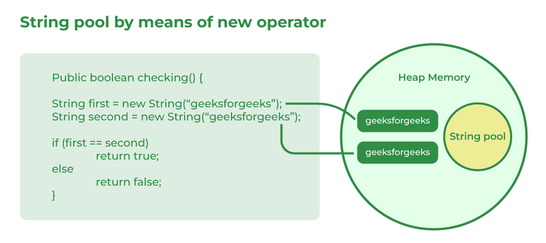

52. What is an array in Java?
An array in Java is a data structure used to store multiple values of the same data type in a single variable. It allows elements to be stored and accessed using an index.
- Arrays store elements in contiguous memory locations and have a fixed size once created.
- Each element is accessed using its index, which starts from 0.
- Arrays improve code readability and make it easier to manage large amounts of related data.

Syntax
int[] Arr = new int[5];

53. On which memory arrays are created in Java?
In Java, array objects are created in heap memory, which is used for dynamic memory allocation during program execution.
- If the array variable is a local variable, its reference is stored in the stack memory, while it points to the array object in the heap.
- Heap memory allows arrays to be shared and accessed by different parts of the program through references.

54. What are the types of an array?
There are two types of arrays i.e., Primitive arrays and References Arrays.
1. Single-Dimensional Arrays: Arrays that have only one dimension i.e., an array of integers or an array of strings are known as single-dimensional arrays.
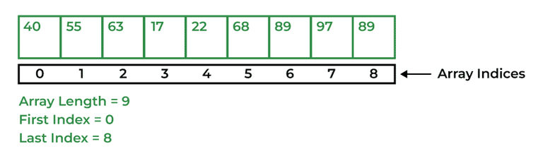
Syntax:
data_type[] Array_Name = new data_type[ArraySize];
2. Multi-Dimensional Arrays: Arrays that have two or more dimensions such as two-dimensional or three-dimensional arrays.
Syntax:
data_type[dim1][dim2]...[dimN] array_name = new data_type[size1][size2]...[sizeN];

55. Why does the Java array index start with 0?
The index of an array signifies the distance from the start of the array. So, the first element has 0 distance therefore the starting index is 0.
Syntax:
[Base Address + (index * no_of_bytes)]

56. What is the difference between int array[] and int[] array?
Both int array[] and int[] array are used to declare an array of integers in java. The only difference between them is on their syntax no functionality difference is present between them.
int arr[] is a C-Style syntax to declare an Array.
int[] arr is a Java-Style syntax to declare an Array.
However, it is generally recommended to use Java-style syntax to declare an Array. As it is easy to read and understand also it is more consistent with other Java language constructs.

57. How to copy an array in Java?
In Java, there are multiple ways to copy an array based on the requirements:
1. clone() Method (Shallow Copy)
- The clone() method creates a new array with its own memory but contains references to the same objects for non-primitive data types.
- For primitive arrays, it behaves like a deep copy since primitive values are directly copied.
int[] arr = {1, 2, 3, 5, 0};
int[] tempArr = arr.clone(); // Creates a new array with copied values
2. System.arraycopy() Method (Deep Copy)
- This method creates a new array and copies elements from the original array.
- It allows partial copying by specifying an offset and length.
int[] arr = {1, 2, 7, 9, 8};
int[] tempArr = new int[arr.length];
System.arraycopy(arr, 0, tempArr, 0, arr.length);
3. Arrays.copyOf() Method (Creates New Array)
- This method creates a new array and copies the entire original array into it.
- If the specified length is greater than the original array, extra elements are initialized with default values.
int[] arr = {1, 2, 4, 8};
int[] tempArr = Arrays.copyOf(arr, arr.length);
4. Arrays.copyOfRange() Method (Copying a Subset)
- Similar to copyOf(), but allows copying a specific range of elements.
int[] arr = {1, 2, 4, 8};
int[] tempArr = Arrays.copyOfRange(arr, 0, arr.length);

58. What do you understand by the jagged array?
A jagged array is an array of arrays in which each row can have a different number of elements. Unlike a regular multidimensional array, all rows are not required to have the same size.
- It helps save memory when different rows require different amounts of storage.
- In Java, a two-dimensional array is internally implemented as an array of arrays, making jagged arrays possible.
Syntax:
int[][] Arr = new int[][] {
{1, 2, 8},
{7, 5},
{6, 7, 2, 6}
};

59. Is it possible to make an array volatile?
Yes, an array reference can be declared as volatile in Java. However, the volatile keyword applies only to the array reference, not to the individual elements of the array.
- When an array is declared volatile, changes to the reference are immediately visible to all threads.
- Modifying an element of the array does not make that change automatically thread-safe or visible through volatile.
- For thread-safe updates to array elements, additional synchronization mechanisms may be required.
Example:
volatile int[] numbers = new int[5];
Here, numbers is a volatile reference to an array, but the elements numbers[0], numbers[1], etc., are not volatile.

60. What are the advantages and disadvantages of an array?
An array is a simple and efficient data structure used to store multiple elements of the same data type. It provides fast access to elements but has some limitations regarding size and flexibility.
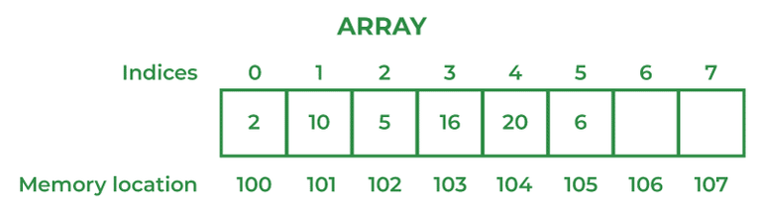

The advantages of Arrays are
- Arrays provide fast access to elements using their index.
- They store elements in contiguous memory locations, improving performance.
- Arrays are easy to use and suitable for storing large amounts of similar data.

Disadvantages of Arrays are
- Arrays have a fixed size, which cannot be changed after creation.
- They can store only homogeneous (same type) elements.
- Inserting or deleting elements can be inefficient because existing elements may need to be shifted.

61. What is an object-oriented paradigm?
The object-oriented paradigm is a programming approach that organizes software around objects, which contain both data (attributes) and behavior (methods). It helps in building modular, reusable, and maintainable applications.
- It is based on key concepts such as Encapsulation, Inheritance, Polymorphism, and Abstraction.
- It improves code reusability, scalability, and maintainability by promoting modular design.

62. What are the main concepts of OOPs in Java?
Object-Oriented Programming (OOP) in Java is based on four fundamental concepts that help in designing modular, reusable, and maintainable applications.
- Encapsulation: Bundles data and methods into a single unit (class) and restricts direct access to data using access modifiers.
- Inheritance: Allows one class to acquire the properties and behaviors of another class, promoting code reusability.
- Polymorphism: Enables a single interface or method to perform different actions depending on the object or context.
- Abstraction: Hides implementation details and exposes only the essential features to the user.

